Session 2026-2027

Vision:Dream of where you want. | Mission: Means to achieve Vision

Program Educational Objectives of the program (PEO): (broad statements that describe the professional and career accomplishments)
PEO1 | Preparation | P: Preparation | Pep-CL abbreviation  pronounce as Pep-si-lL easy to recall
PEO2 | Core Competence | E: Environment (Learning Environment) | Pep-CL abbreviation  pronounce as Pep-si-lL easy to recall
PEO3 | Breadth | P: Professionalism | Pep-CL abbreviation  pronounce as Pep-si-lL easy to recall
PEO4 | Professionalism | C: Core Competence | Pep-CL abbreviation  pronounce as Pep-si-lL easy to recall
PEO5 | Learning Environment | L: Breadth (Learning in diverse areas) | Pep-CL abbreviation  pronounce as Pep-si-lL easy to recall

Program Outcomes (PO): (statements that describe what a student should be able to do and know by the end of a program)
Keywords of POs:
Engineering knowledge,Problem analysis, Design/development of solutions,Conduct Investigations of Complex Problems, Engineering Tool Usage, The Engineer and The World,Ethics, Individual and Collaborative Team work,Communication, Project Management and Finance, Life-Long Learning

PSO Keywords: Cutting edge technologies, Research

“I am an engineer, and I know how to apply engineering knowledge to investigate, analyse and design solutions to complex problems using tools for entire world following all ethics in a collaborative way with proper management skills throughout my life.” to contribute to the development of cutting-edge technologies and Research.

Integrity: I will adhere to the Laboratory Code of Conduct and ethics in its entirety.

Name and Signature of Student and Date
(Signature and Date in Handwritten)

Session | 2024-25 (ODD) |  | Course Name | Web Technology Lab
Semester | 3 |  | Course Code | 23CT1301
Roll No | 56 |  | Name of Student | Prashik Fulzele
Practical Number |  | 3
Course Outcome |  | - Understand various internet technologies.  - Design the web pages using HTML and CSS.  - Implement the XML technology to store the data.  - Develop the interactive web pages using JavaScript.
Aim |  | Develop and demonstrate the usage of inline, internal and external style sheet using CSS.
Problem Definition |  | To design a web page and apply styling to HTML elements using three different CSS embedding methods (Inline, Internal, and External CSS), demonstrating how selectors and properties control page presentation.
Theory  (100 words) |  | Cascading Style Sheets (CSS) describe how HTML elements are displayed on screen, paper, or in other media. CSS saves work by controlling the layout of multiple web pages simultaneously.  CSS can be added to HTML documents in 3 ways:  - Inline CSS: Applied directly to an HTML element using the style attribute. Useful for quick, single-element styling.  - Internal (Embedded) CSS: Defined within the <style> tag inside the <head> section of an HTML document. Ideal for styling a single document.  - External CSS: Linked to the HTML document via the <link> tag pointing to a separate .css file. Best practice for styling multiple pages consistently across a website.
Procedure and Execution  (100 Words) |  | Step for Implementation:  - Open a text editor (such as VS Code, Notepad, or Sublime Text).  - Create an external stylesheet file named style.css and define generic layout rules for the body and headers.  - Create an HTML file named practical3.html.  - Link the external stylesheet in the <head> section using <link rel="stylesheet" href="style.css">.  - Add an internal stylesheet within the <head> block using <style>...</style> to define page-specific element styles.  - Create page content inside the <body> and apply inline styles to specific elements using the style="..." attribute.  - Save both files in the same folder and open practical3.html in a web browser to verify style cascading and priority.
Code:
body {
background-color: #f2f2f2;
}

.form-container {
width: 450px;
margin: 30px auto;
background-color: #ffffff;
padding: 20px;
border: 2px solid #333333;
border-radius: 8px;
}

h2 {
text-align: center;
color: #333333;
margin-top: 0;
}

.field {
margin-bottom: 15px;
}

label {
display: block;
font-weight: bold;
margin-bottom: 5px;
}

label.inline-label {
display: inline;
font-weight: normal;
margin-right: 10px;
}

input[type="text"],
input[type="email"],
input[type="tel"],
input[type="date"],
input[type="password"],
select,
textarea {
width: 100%;
padding: 8px;
border: 1px solid #777777;
border-radius: 4px;
box-sizing: border-box;
}

.buttons {
text-align: center;
margin-top: 20px;
}

input[type="submit"],
input[type="reset"] {
padding: 10px 20px;
font-size: 14px;
font-weight: bold;
cursor: pointer;
border: 1px solid #333333;
border-radius: 4px;
}

input[type="submit"] {
background-color: #4CAF50;
color: white;
}

input[type="reset"] {
background-color: #f44336;
color: white;
}

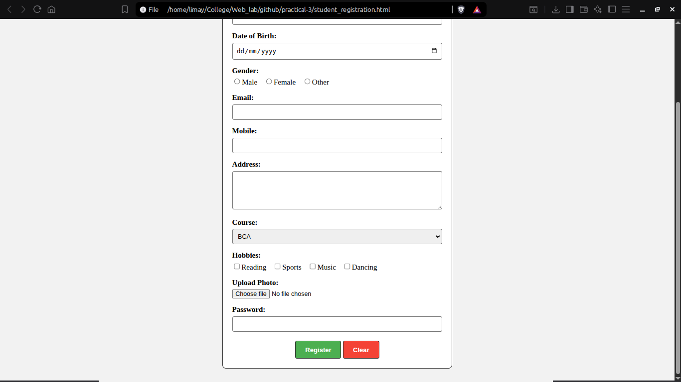
Output: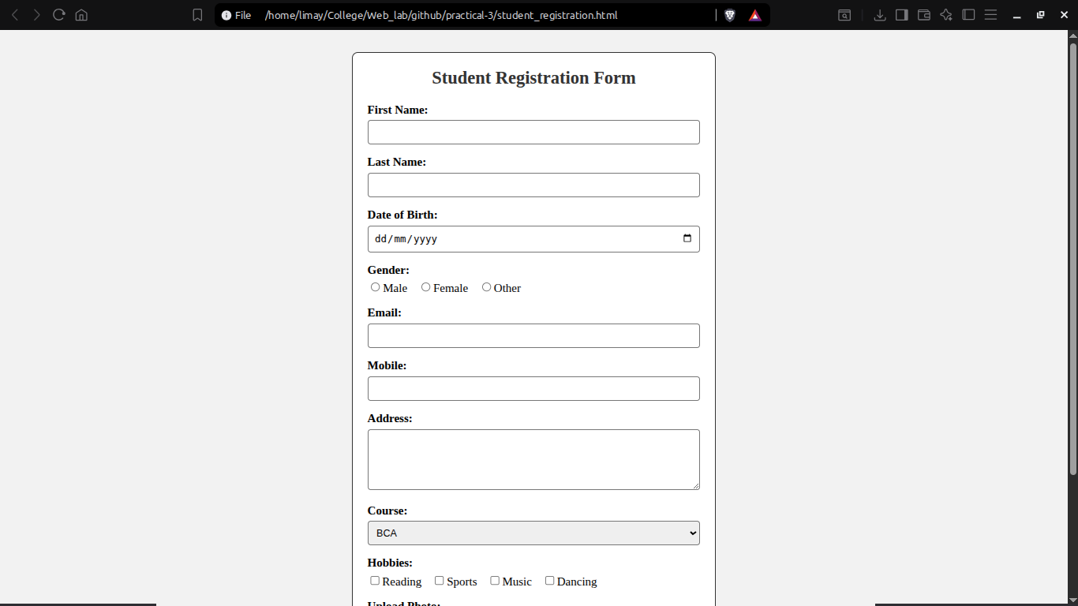
Output Analysis |  | The browser correctly parsed and applied all three methods of CSS. External styles governed global document structure, Internal styles formatted specific container blocks, and Inline styles successfully overrode default rules for target elements.
Link of student Github profile where lab assignment has been uploaded |  | https://github.com/Prashikf703-byte
Conclusion |  | Successfully created and verified a web page demonstrating the implementation and presentation behavior of Inline, Internal, and External CSS style sheets.
Plag Report (Similarity index < 12%) |  | 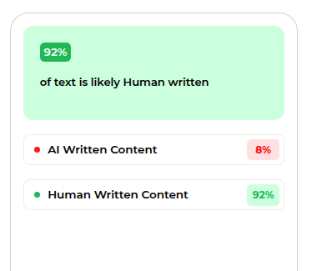
Date |  | 21/07/2026

